____________________________________________________________________________

**Class Name:** distributionT

**Method Name:** gammaFunction

**Parameters:** x

**Pseudocode:**

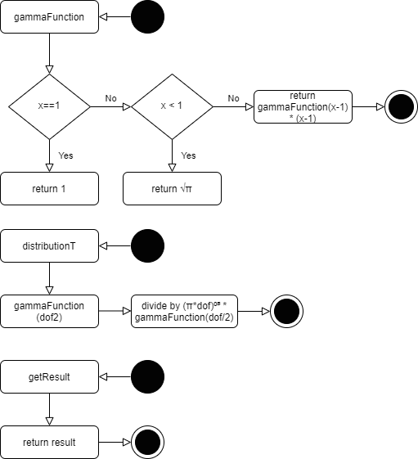

if x == 1

return 1;

if x < 1

return sqrt(PI);

else

return (x-1) * gammaFunction(x-1);

____________________________________________________________________________

**Class Name:** distributionT

**Method Name:** distributionT

**Parameters:** dof, dof2

**Pseudocode:**



gammaFunction(dof2) / ((pow(dof*PI,0.5))*gammaFunction(dof/2));

____________________________________________________________________________

**Class Name:** distributionT

**Method Name:** getResult

**Parameters:** none

**Pseudocode:**



Return result

____________________________________________________________________________

**Class Name:** Getter

**Method Name:** calculate

**Parameters:** currX, dof, dof2

**Pseudocode:**

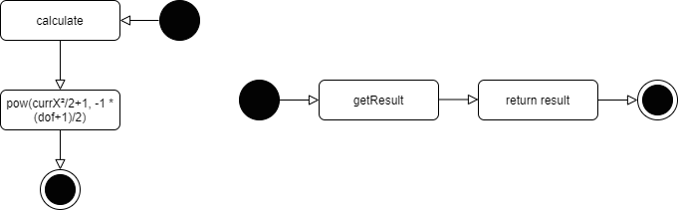

Return pow((currX * currX) / dof+1, -1 * ((dof + 1) / 2));

____________________________________________________________________________

**Class Name:** Getter

**Method Name:** getResult

**Parameters:** none

**Pseudocode:**



Return result

____________________________________________________________________________

**Class Name:** SimpsonDistribution

**Method Name:** calculate

**Parameters:** x, dof, num_seg

**Pseudocode:**

calculate(0, dof, (dof+1)/2);

finalResult += distT.getResult() * getterObj.getResult() * w/3;

while (i smaller than num_seg) {

if (currX == 0)

end

else if (i % 2 == 0)

Calculate with multiplier 2

else {

Calculate with multiplier 4

}

Increment i

}

____________________________________________________________________________

**Class Name:** main

**Method Name:** main

**Parameters:** none

**Pseudocode:**

